ref. 54030
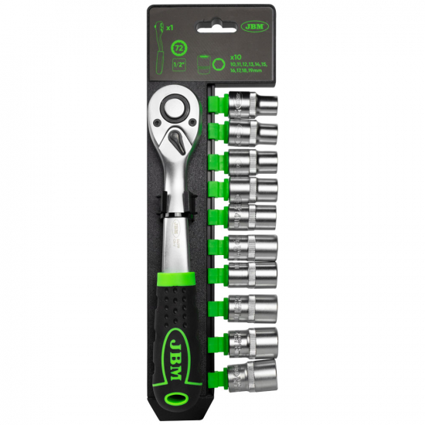
CARRACA 72 DIENTES CON VASOS HEXAGONALES 1/4"

Medidas
4, 5, 6, 7, 8, 9, 10, 11, 12, 13mm

